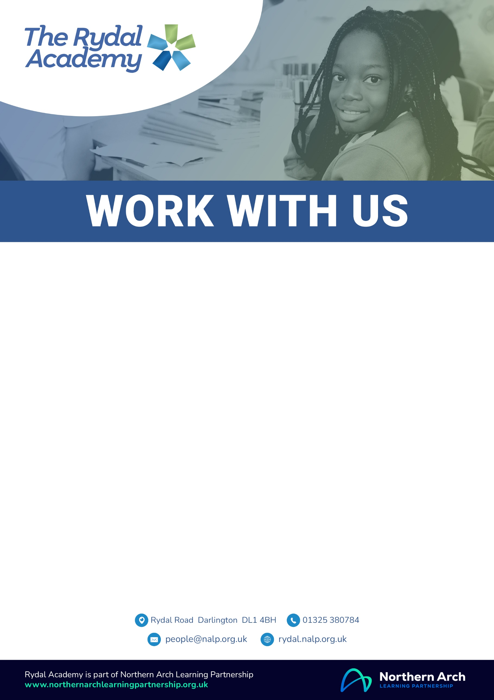

Teaching Assistant

Permanent, 37 hours per week, 39 working weeks, (Term time plus 5 days, 47 paid weeks including holiday)

NJC Band 7, point 14-17, £25,800 - £27,095 per annum

To commence September 2025

We require an enthusiastic and skilled Teaching Assistant to join our team in a large, unique and diverse primary school and nursery which puts pupils and the school community at its heart. We are looking for a creative, adaptable and reflective practitioner who uses the latest research to support all pupil groups.

In return we can offer: the opportunity to experience a number of roles including supporting Nursery to Year 6, SEND support, and pastoral support roles, high quality in-house coaching and mentoring; access to a wide range of professional development opportunities; a skilled, supportive and experienced team; an exceptional curriculum; a highly supportive and collaborative staff; amazing children.

For further information or to discuss the post please contact Mr John Armitage, Headteacher 01325 380784 or by e-mail to [jarmitage@rydal.nalp.org.uk](mailto:jarmitage@tra.inicioacademies.org.uk).

Information for applicants, including the job description and person specification for this role and an on-line application form, can be viewed at <https://nalp.face-ed.co.uk/vacancies> If you have any difficulties completing the on-line application form, please contact Sam Recruit on 01924 907319 or the Schools HR Team on [people@nalp.org.uk](mailto:people@nalp.org.uk).

**Closing date:** **Midday, 9th June 2025** **Interviews: 18th June 2025**

Northern Arch Learning Partnership and its partner schools are passionate about safeguarding the welfare of pupils and maximising their life chances. We expect all staff and volunteers to share this commitment. This post is subject to a satisfactory enhanced Disclosure and Barring Service criminal records check for work